KATARINA CEHOVSKI

ASSIGNMENT B

**Request 1**

List the last name, first name and employee number of all employees that have a last name starting with M.

**Expected**

3 columns  
Last_Name, First_Name, Employee_No  
Marsh, Adam, 125  
…

**Query**

SELECT Last_Name, First_Name, Employee_no FROM Employees

WHERE Last_Name LIKE 'M%'

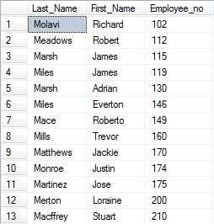

**Request 2**

List the department number, last name, first name and phone number of all sales representatives who were hired on or after 24 Mar 1998 sorted in ascending order of last name.

**Expected**

4 columns  
Department_No, Last_Name, First_Name, Phone_Number  
40, Button, Joshua, 456 456 412  
…

**Query**

SELECT e.Department_No, e.Last_Name, e.First_Name, e.Phone_Number FROM Employees e

JOIN Jobs j ON e.Job_ID= j.Job_ID

WHERE j.Job_Title = 'Sales Representative' AND Hire_Date>= '1998-03-24'

ORDER BY Last_Name ASC

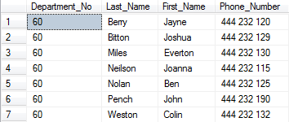

**Request 3**

List all the data for all jobs where the minimum salary is less than or equal to 4500 sorted in descending order of the minimum salary.

**Expected**

4 columns  
Job_ID, Job_Title, Min_Salary, Max_Salary  
IT_SOFT_DEV, Software Developer, 4500, 15000  
…

**Query**

SELECT * FROM Jobs

WHERE Min_Salary<= 4500 ORDER BY Min_Salary DESC

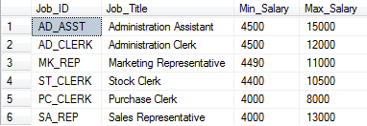

**Request 4**

Which jobs are found in the Marketing and Accounting departments?

**Expected**

1 column  
Job_Title  
Accountant  
…

**Query**

SELECT DISTINCT j.Job_Title FROM Jobs j

JOIN Employees e ON e.Job_ID = j.Job_ID

JOIN Departments d ON d.Department_No = e.Department_No

WHERE Department_Name in ('Marketing', 'Accounting')

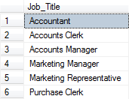

**Request 5**

List the department name, location, last name and salary of employees who work in location 1700 sorted in ascending order of department name.

**Expected**

4 columns  
Department_Name, Location_ID, Last_Name, Annual_Salary  
Finance, 1700, Rogers, 25000.00  
…

**Query**

SELECT d.Department_Name, d.Location_ID, e.Last_Name, e.Annual_Salary

FROM Employees e

JOIN Departments d ON e.Department_No= d.Department_No

WHERE d.Location_ID =1700

ORDER BY Department_Name ASC

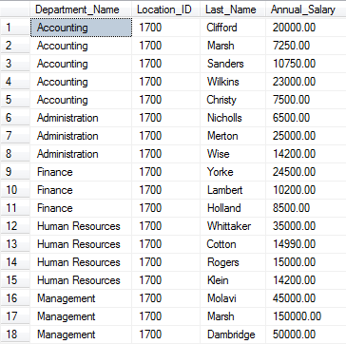

**Request 6**

List the last name and first name for all employees who were hired in the months of June or August (for all years) sorted in ascending order of last name.

**Expected**

2 columns  
Last_Name, First_Name  
Cehovski, Katarina  
…

**Query**

SELECT Last_Name, First_Name FROM Employees

WHERE MONTH(Hire_Date) = 6 OR MONTH(Hire_Date) = 8

ORDER BY Last_Name ASC

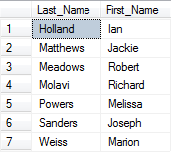

**Request 7**

Show the average salary for employees for one year (rounded to 2 decimal places).

**Expected**

1 column with number  
15464.15

**Query**

SELECT CAST(AVG(Annual_Salary) AS DECIMAL (8,2)) AS Average_Salary FROM Employees



**Request 8**

Show the total monthly salaries figure (0 decimal places) for all employees in departments 80 and 60.

**Expected**

1 column with number  
14523

**Query**

SELECT CAST(SUM(Annual_Salary/12) as INT) AS Total_Montly_Salary FROM Employees

WHERE Department_No IN (80, 60)



**Request 9**

List the department number, department name and the number of employees for each department that has less than 4 employees grouping by department number and department name.

**Expected**

3 columns  
Department_No, Department_Name, Number_of_Employees  
50, IT, 3  
…

**Query**

SELECT d.Department_No, d.Department_Name, COUNT(*) AS Number_of_Employees

FROM Departments d JOIN Employees e

ON e.Department_No= d.Department_No

GROUP BY d.Department_No, d.Department_Name

HAVING COUNT(*)< 4

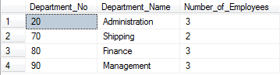

**Request 10**

List the department number, department name and the number of employees for the department that has the lowest number of employees using appropriate grouping.

**Expected**

3 columns  
Department_No, Department_Name, Number_of_Employees  
60, Finance, 1

**Query**

SELECT TOP 1 d.Department_No, d.Department_Name, COUNT(*) as Number_of_Employees

FROM Departments d JOIN Employees e

ON d.Department_No = e.Department_No

GROUP BY d.Department_No, d.Department_Name

ORDER BY Number_of_Employees ASC



**Request 11**

List the department number and name for all departments where no sales representatives work.

**Expected**

2 columns  
Department_No, Department_Name  
40, Administration  
…

**Query**

SELECT d.Department_No, d.Department_Name FROM Departments d

WHERE d.Department_No NOT IN

(

SELECT DISTINCT e.Department_No FROM Employees e

JOIN Jobs j ON j.Job_ID= e.Job_ID

JOIN Departments d1 ON d1.Department_No = e.Department_No

AND j.Job_Title = 'Sales Representative'

)

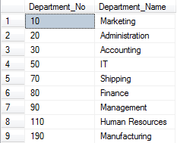

**Request 12**

Add the following new job IT_ASST, IT Assistant, 5000, 8000

**Expected**

New row will be added in table Jobs:  
Job_ID, Job_Title, Min_Salary, Max_Salary  
IT_ASST, IT Assistant, 5000, 8000

**Query**

INSERT INTO Jobs VALUES ('IT_ASST', 'IT Assistant', 5000, 8000)

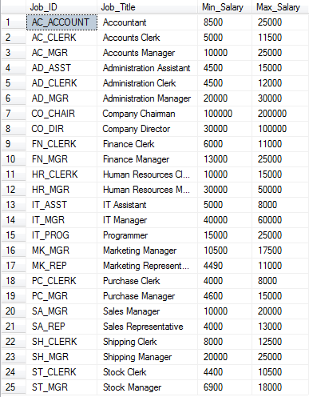

**Request 13**

Update all the minimum salaries for jobs with an increase of 500.

**Expected**

4 columns  
column Min_Salary -> Before: 5500, After: 6000

**Query**

UPDATE Jobs SET Min_Salary+= 500

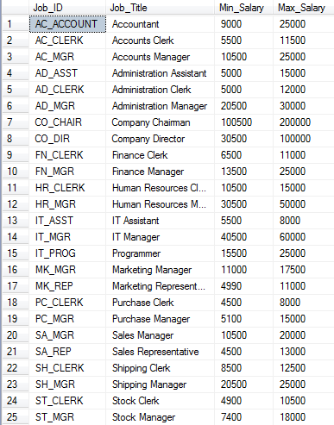

**Request 14**

List all the data for jobs sorted in ascending order of job id.

**Expected**

4 columns  
Job_ID, Job_Title, Min_Salary, Max_Salary  
AC_ACCOUNT, Accountant, 9000, 15000

**Query**

SELECT * FROM Jobs ORDER BY Job_ID ASC

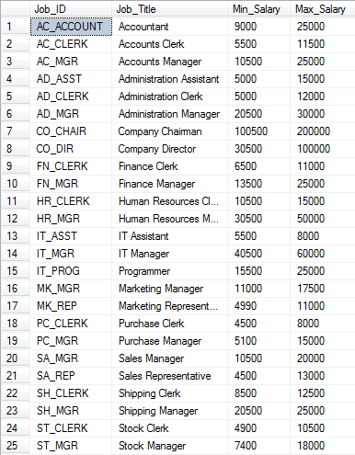

**Request 15**

The database administrator has found the following entity-relationship diagram. He thinks that the diagram is incorrect. Check the diagram and draw a corrected diagram.

**Expected**

Diagram with changed arrow, pointing from Departments to Locations.

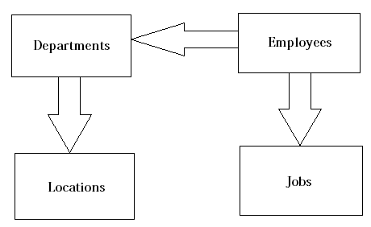

**Request 16**

Print a copy of the data dictionary entry for the table departments.

**Expected**

Data dictionary will be displayed.

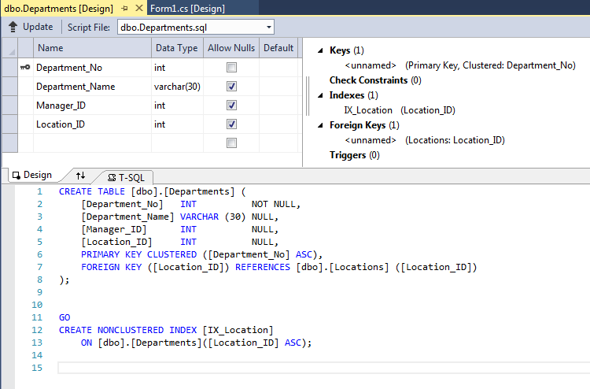

**Request 17**

Drop the table for job history.

**Expected**

Table Job_History will no longer exist.

**Query**

DROP TABLE Job_History



**Request 18**

Create a new table called SAL_HISTORY to include the fields EMPID, FIRSTNAME, LASTNAME, HIREDATE and SAL with the same data types as the employees table. The EMPID must not be NULL.

**Expected**

New table will be added. Table will have 5 columns: EMPID, FIRSTNAME, LASTNAME, HIREDATE, SAL.

**Query**

CREATE TABLE SAL_HISTORY

(

EMPID INT NOT NULL,

FIRSTNAME VARCHAR (20),

LASTNAME VARCHAR (25) NOT NULL,

HIREDATE DATETIME NOT NULL,

SAL DECIMAL (8, 2)

)



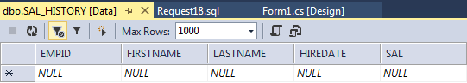

**Request 19**

Insert data from the employees table where the employee number is less than or equal to 130 into the SAL_HISTORY table.

**Expected**

Data from table Employee table will be added in table SAL_HISTORY.

**Query**

INSERT INTO SAL_HISTORY

SELECT Employee_No, First_Name, Last_Name, Hire_Date,

Annual_Salary FROM Employees WHERE Employee_No<=130



**Request 20**

Display all the records and all the fields in the SAL_HISTORY table.

**Expected**

4 columns  
EMPID, FIRSTNAME, LASTNAME, HIREDATE, SAL  
125, Katarina, Cehovski, 12/12/2012, 12000  
…

**Query**

SELECT * FROM SAL_HISTORY

